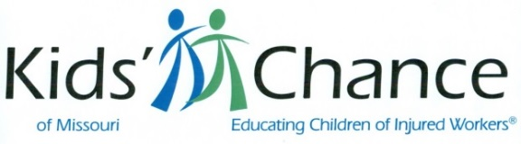

Save The Date – 2020

St Louis Golf – St Louis
August 14 – The Legends Golf Club

Kansas City Golf & CLE - Kansas City
August 31 - Oakwood Country Club

Trivia Night – Columbia
September 10 – Columbia Country Club

Networking Event – Cape Girardeau
October 8 – Top of the Marq

St Louis CLE – St Louis
Sept 25 – Hyatt Regency St Louis at the Arch

Texas Hold’em – Kansas City
October 24 - Lee’s Summit VFW

Trivia Night – Springfield
Fall TBD – Venue TBD

SW Missouri CLE – Joplin
TBD – Venue TBD

Trivia Night – St Louis
October 24 – Jewish Community Center/Creve Coeur

Questions? Contact:
Jim Susman: susgroup@gmail.com
Or visit our website at: www.mokidschance.org

