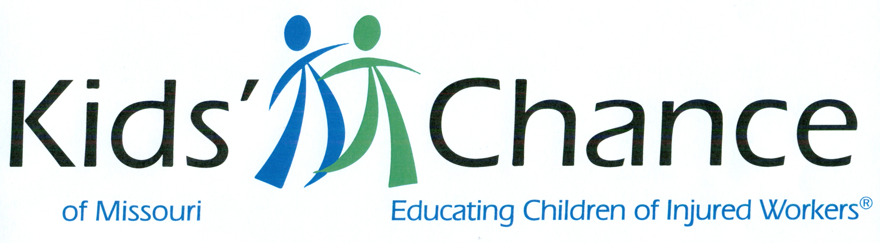

WORKERS’ COMPENSATION CLE SEMINAR 2020
Hyatt Regency St. Louis at the Arch
Friday, September 25, 2020
8.6 HOURS OF MISSOURI CLE CREDITS –
INCLUDING 2 hours of Ethics and 1 hour Diversity
Hours are due 9-30-2020

7:45 a.m. Registration & Continental Breakfast/Coffee

8:00 a.m. A View from the Director’s Chair
- Presented by Colleen Joern Vetter, Director, Missouri Division of Workers’ Compensation

8:30 a.m. Diversity and Inclusion
- Presented by Panel- Colleen Joern Vetter, Director, Missouri Division of Workers’ Compensation; Dr Alisa Warren, Executive Director, Missouri Commission on Human Rights

9:20 a.m. Second Injury Fund Update
- Presented by Cara Harris, Chief Counsel, Labor Division- Office of MO Attorney General

10:10 a.m. Break

10:20 a.m. Conservative Care and Pain Management
- Presented by Dr. Brian Meek

11:10a.m Legislative update
- Presented by Mark Moreland, Law Offices of Mark Moreland LLC

Noon Lunch — on your own

1:00 pm Legal and Medical Issues in WC Drug/Alcohol Defenses
- Presented by Steve McManus, MVP; Dr. Sarah Riley, Associate Professor Pathology and Director, Forensic Toxicology Laboratory, St Louis University

1:50 p.m. Ethics 1: The Rules of Professional Conduct
- Presented by Paige Tungate, Downey Law Group LLC

2:40 p.m. Break

2:50 p.m. Ethics 2: The Rules of Professional Conduct
- Presented by Paige Tungate, Downey Law Group LLC

3:40 p.m. Case Law Review
- Presented by B. Michael Korte, Law Offices of B. Michael Korte LLC, and Chris Archer, Archer and Lassa, LLC.

4:30 p.m. Adjourn

Workers’ Compensation CLE Seminar 2020

Registration Form
Send this form with your check, payable to KIDS’ CHANCE Inc. of Missouri, for the amount due
To: KIDS’ chance Inc. of Missouri, P.O. Box 410384, St. Louis, MO 63141
314/997-3390 or susgroup@gmail.com

Name _____________________________________________________________________________________
E-mail ____________________________________________________________________________________
Firm or Company ___________________________________________________________________________
Address ___________________________________________________________________________________
City/State/Zip ______________________________________________________________________________
Phone ____________________________________________________________________________________
Names of Additional Attendees _________________________________________________________________
____________________________________________________________________________________

[ ] $275 per person [ ] Check enclosed [ ] Credit Card

Credit Card Charges (VISA, MasterCard or American Express)
Name ___________________________________________________________________
Firm ____________________________________________________________________
Credit Card # __________ - __________ - __________ - __________
Exp. Date __________________ 3 digits on back of card __________
American Express Cards — 4 digits on the front of the card _______________
Billing Statement Zip Code ____________________________

.

KIDS’ CHANCE is a nonprofit corporation that provides educational scholarships to financially assist the children of workers who have been seriously injured or killed in Missouri work related injuries. All proceeds from this event will be used to fund scholarships.

