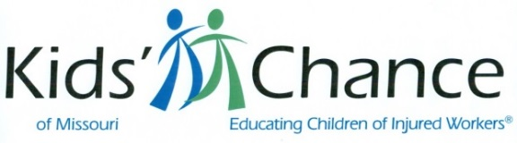

Save The Date – 2020

Networking Event – Cape Girardeau
April 16 – Top of the Marq

Trivia Night – Columbia
April 30 – Columbia Country Club

Lake Golf – Osage Beach
May 3 – The Oaks @ Margaritaville

St Louis Golf – St Louis
May 15 – The Legends Golf Club

St Louis CLE – Kansas City
TBD – Venue TBD

St Louis CLE – St Louis
June 5 – SLU Law School

Texas Hold’em – Kansas City
July 18 - Lee’s Summit VFW

Kansas City golf – Kansas City
August 31 - Oakwood Country Club

Trivia Night – Springfield
Fall TBD – Venue TBD

Trivia Night – Cape Girardeau
October 3 – Venue TBD

Trivia Night – St Louis
October 24 – Jewish Community Center/Creve Coeur

Questions? Contact:
Jim Susman: susgroup@gmail.com
Or visit our website at: www.mokidschance.org

